**ExtUnlockfunction**

**Aras Innovator Community Projects**

**Description**

**What is “ExtUnlockfunction”**

* This function allows non-Administrator User to “forcedly” unlock data locked by other users.
* Of course, it is no good to unlock data as much as one likes. Functional restriction according to “Identity” and “Item Type” makes it possible to give the authority to unlock.

**Deploy documentation**

1. Copy folders below a Client folder to Aras Innovator folders below a Client folder.
2. Import packages below a Package folder into Aras Innovator. To import, please, use Aras Innovator utility tool.
3. We provide Japanese language support using LanguagePackManagementUtility.
4. Please, set “Identity” and “Item Type” that give authority to unlock with “extendable unlock functionality” if necessary

**Folder layout**

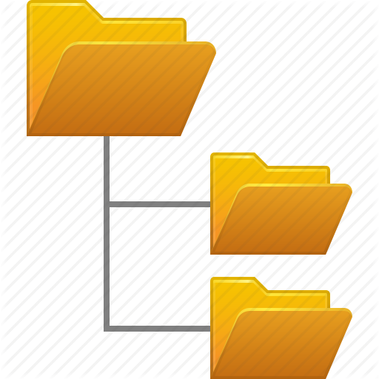

Installation destination/Innovator

javascript

Client

**Screen shot**

Screen shot on the left shows how to set the authority to unlock according to “Identity” and “Item Type” restrictions.

For example, User 1 is given the authority to unlock Item Type “Document”.

User 1, who has been given the authority to unlock, has searched for “Document” that has been locked by User 2.

Naturally, locked condition means that someone else locked it and usually no one can unlock it.

However, as User 1 has been given the special authority to unlock, he is able to unlock the document instead of User 2.

In terms of “exclusive control”, it is no good to give everybody the “forcible unlock” function. However, it is possible to control the scope and give the authority, and it helps to minimize risks and improve the operation efficiency.

Notice that only the local person in charge can give the authority to unlock.

**Release Version**

Correspond to 2.00 Ver11SP6 (May 18, 2016)